**CNNs**

CNNs understand the structure of multi-dimensional data.

MLP will need to decompose a 2D image into a 1D vector, CNNs will not do this.

(Done! MNIST miniproject complete)

[https://github.com/udacity/deep-learning-v2-pytorch/blob/master/convolutional-neural-networks/mnist-mlp/](https://github.com/udacity/deep-learning-v2-pytorch/blob/master/convolutional-neural-networks/mnist-mlp/mnist_mlp_solution_with_validation.ipynb)

**Local connectivity**

MLPs

1. only use fully connected layers. 26x26 used half a million parameters
2. Only accept vectors as inputs

CNNs

1. Use sparsely connected layers
2. Accept a matrix as input

Locally connected layers uses less parameters, and is less prone to overfitting, since each connection is to a region in the input layer. Parameters / weights can be shared between each of the hidden nodes corresponding to a different region.

Fully connected: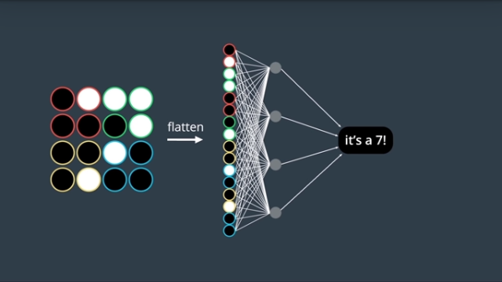

Sparsely Connected:

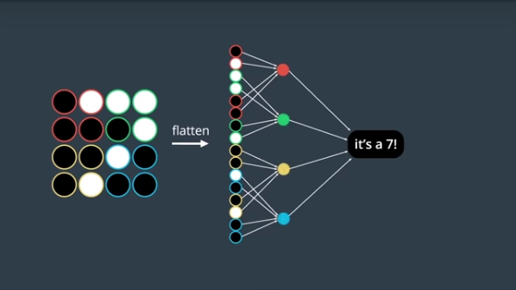

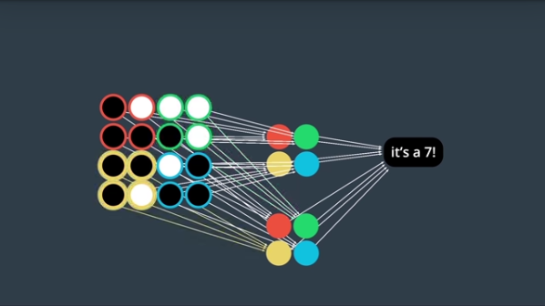

**Convolutional Layer**

At each node, the window defines a piece of the image. Since they share weights it is a kind of convolution. 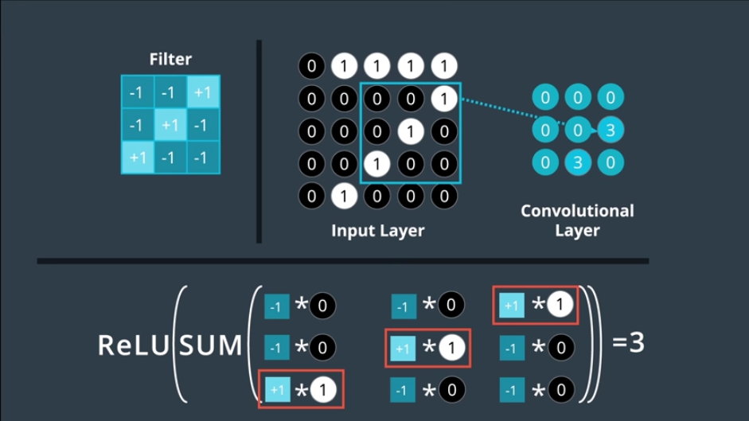

Need filters for teeth, whiskers, and tongue, to recognize a region of a dog.

2D rgb image, a 3D filter with the depth being 3 for r, g, and b.

For an image with end up with multiple 3D arrays for a conv layer. This can be input to yet another conv layer. Patterns within patterns within patterns.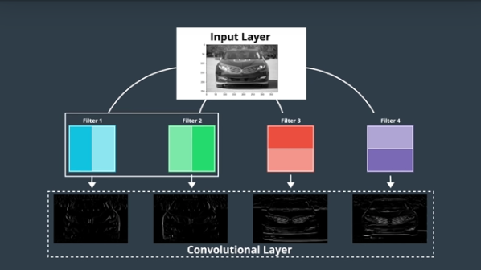

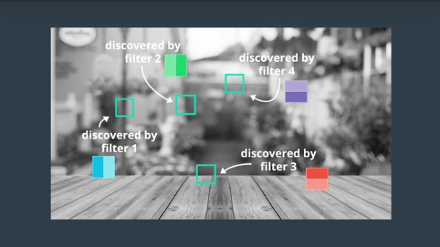

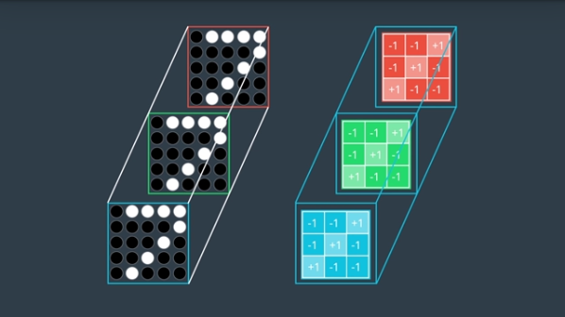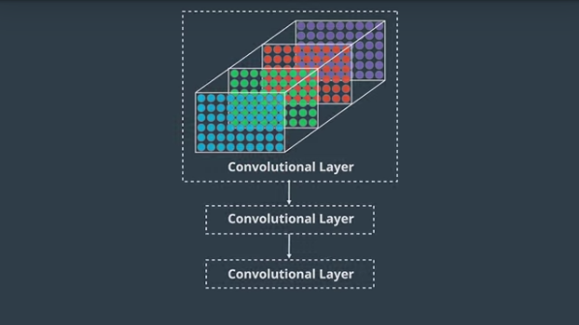

Number of filters for number of features. Size of filters for the size of the features. Can use stride to determine how much to slide each filter, the spacing between filters.

We can also pad the image with zeros to account for the edges of the input data to get features at the edge

**Convolutional Layers in Keras**

To create a convolutional layer in Keras, you must first import the necessary module:

from keras.layers import Conv2D

Then, you can create a convolutional layer by using the following format:

Conv2D(filters, kernel_size, strides, padding, activation='relu', input_shape)

Arguments

You must pass the following arguments:

filters - The number of filters.

kernel_size - Number specifying both the height and width of the (square) convolution window.

There are some additional, optional arguments that you might like to tune:

strides - The stride of the convolution. If you don't specify anything, strides is set to 1.

padding - One of 'valid' or 'same'. If you don't specify anything, padding is set to 'valid'.

activation - Typically 'relu'. If you don't specify anything, no activation is applied. You are strongly encouraged to add a ReLU activation function to every convolutional layer in your networks.

NOTE: It is possible to represent both kernel_size and strides as either a number or a tuple.

When using your convolutional layer as the first layer (appearing after the input layer) in a model, you must provide an additional input_shape argument:

input_shape - Tuple specifying the height, width, and depth (in that order) of the input.

NOTE: Do not include the input_shape argument if the convolutional layer is not the first layer in your network.

<https://keras.io/layers/convolutional/>

Example #1

Say I'm constructing a CNN, and my input layer accepts grayscale images that are 200 by 200 pixels (corresponding to a 3D array with height 200, width 200, and depth 1). Then, say I'd like the next layer to be a convolutional layer with 16 filters, each with a width and height of 2. When performing the convolution, I'd like the filter to jump two pixels at a time. I also don't want the filter to extend outside of the image boundaries; in other words, I don't want to pad the image with zeros. Then, to construct this convolutional layer, I would use the following line of code:

Conv2D(filters=16, kernel_size=2, strides=2, activation='relu', input_shape=(200, 200, 1))

Example #2

Say I'd like the next layer in my CNN to be a convolutional layer that takes the layer constructed in Example 1 as input. Say I'd like my new layer to have 32 filters, each with a height and width of 3. When performing the convolution, I'd like the filter to jump 1 pixel at a time. I want the convolutional layer to see all regions of the previous layer, and so I don't mind if the filter hangs over the edge of the previous layer when it's performing the convolution. Then, to construct this convolutional layer, I would use the following line of code:

Conv2D(filters=32, kernel_size=3, padding='same', activation='relu')

Example #3

If you look up code online, it is also common to see convolutional layers in Keras in this format:

Conv2D(64, (2,2), activation='relu')

In this case, there are 64 filters, each with a size of 2x2, and the layer has a ReLU activation function. The other arguments in the layer use the default values, so the convolution uses a stride of 1, and the padding has been set to 'valid'.



**Dimensionality**

<https://keras.io/layers/convolutional/>

Just as with neural networks, we create a CNN in Keras by first creating a Sequential model.

We add layers to the network by using the .add() method.

Copy and paste the following code into a Python executable named conv-dims.py:

from keras.models import Sequential

from keras.layers import Conv2D

model = Sequential()

model.add(Conv2D(filters=16, kernel_size=2, strides=2, padding='valid',

activation='relu', input_shape=(200, 200, 1)))

model.summary()

We will not train this CNN; instead, we'll use the executable to study how the dimensionality of the convolutional layer changes, as a function of the supplied arguments.

Run python path/to/conv-dims.py and look at the output. It should appear as follows:

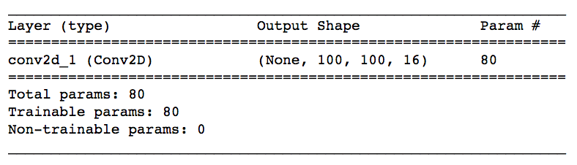

Do the dimensions of the convolutional layer line up with your expectations?

Feel free to change the values assigned to the arguments (filters, kernel_size, etc) in your conv-dims.py file.

Take note of how the number of parameters in the convolutional layer changes. This corresponds to the value under Param # in the printed output. In the figure above, the convolutional layer has 80 parameters.

Also notice how the shape of the convolutional layer changes. This corresponds to the value under Output Shape in the printed output. In the figure above, None corresponds to the batch size, and the convolutional layer has a height of 100, width of 100, and depth of 16

**Formula: Number of Parameters in a Convolutional Layer**

The number of parameters in a convolutional layer depends on the supplied values of filters, kernel_size, and input_shape. Let's define a few variables:

K - the number of filters in the convolutional layer

F - the height and width of the convolutional filters

D_in - the depth of the previous layer

Notice that K = filters, and F = kernel_size. Likewise, D_in is the last value in the input_shape tuple.

Since there are F*F*D_in weights per filter, and the convolutional layer is composed of K filters, the total number of weights in the convolutional layer is K*F*F*D_in. Since there is one bias term per filter, the convolutional layer has K biases. Thus, the number of parameters in the convolutional layer is given by K*F*F*D_in + K.

**Formula: Shape of a Convolutional Layer**

The shape of a convolutional layer depends on the supplied values of kernel_size, input_shape, padding, and stride. Let's define a few variables:

K - the number of filters in the convolutional layer

F - the height and width of the convolutional filters

S - the stride of the convolution

H_in - the height of the previous layer

W_in - the width of the previous layer

Notice that K = filters, F = kernel_size, and S = stride. Likewise, H_in and W_in are the first and second value of the input_shape tuple, respectively.

The depth of the convolutional layer will always equal the number of filters K.

If padding = 'same', then the spatial dimensions of the convolutional layer are the following:

height = ceil(float(H_in) / float(S))

width = ceil(float(W_in) / float(S))

If padding = 'valid', then the spatial dimensions of the convolutional layer are the following:

height = ceil(float(H_in - F + 1) / float(S))

width = ceil(float(W_in - F + 1) / float(S))

**Quiz**

Please change the conv-dims.py file, so that it appears as follows:

from keras.models import Sequential

from keras.layers import Conv2D

model = Sequential()

model.add(Conv2D(filters=32, kernel_size=3, strides=2, padding='same',

activation='relu', input_shape=(128, 128, 3)))

model.summary()

Run python path/to/conv-dims.py, and use the output to answer the questions below.

How many parameters does the convolutional layer have? Correct! The number of parameters is (32 x 3 x 3 x 3) + 32 = 896.

Correct! The depth of a convolutional layer is always equal to the number of filters.

width = ceil(float(W_in) / float(S)) = 64

**Pooling Layers**

Layers add dimensionality, each responsible for finding a pattern in the image. Lots of layers can cause overfitting. Pooling layers address this

Max pooling layer take a stack of pooling layers as input. Define a window size and stride.

Global Pooling Layer

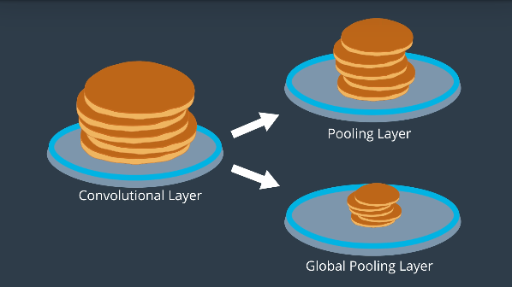

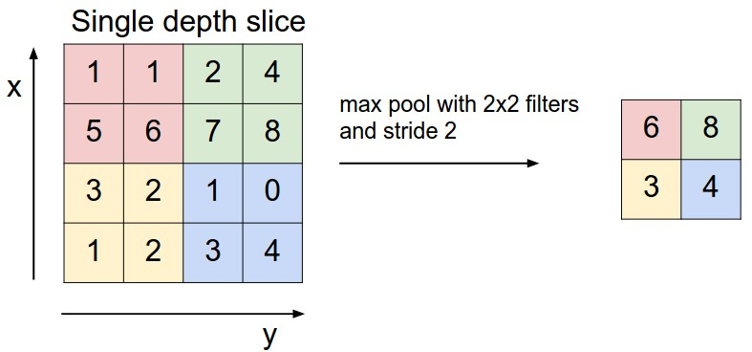

**Max Pooling Layers in Keras**

<https://keras.io/layers/pooling/#maxpooling2d>

To create a max pooling layer in Keras, you must first import the necessary module:

from keras.layers import MaxPooling2D

Then, you can create a convolutional layer by using the following format:

MaxPooling2D(pool_size, strides, padding)

**Example**

Say I'm constructing a CNN, and I'd like to reduce the dimensionality of a convolutional layer by following it with a max pooling layer. Say the convolutional layer has size (100, 100, 15), and I'd like the max pooling layer to have size (50, 50, 15). I can do this by using a 2x2 window in my max pooling layer, with a stride of 2, which could be constructed in the following line of code:

MaxPooling2D(pool_size=2, strides=2)

If you'd instead like to use a stride of 1, but still keep the size of the window at 2x2, then you'd use:

MaxPooling2D(pool_size=2, strides=1)

**Checking the Dimensionality of Max Pooling Layers**

Copy and paste the following code into a Python executable named pool-dims.py:

from keras.models import Sequential

from keras.layers import MaxPooling2D

model = Sequential()

model.add(MaxPooling2D(pool_size=2, strides=2, input_shape=(100, 100, 15)))

model.summary()

Run python path/to/pool-dims.py and look at the output. It should appear as follows:

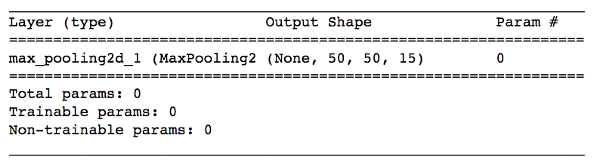

**CNNs for Image Classification**

Often images are of different sizes, but often real-world data is of different sizes. Therefore, we have to resize the image to a common size.

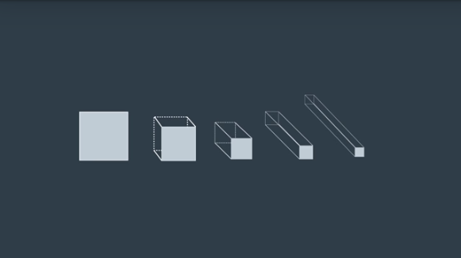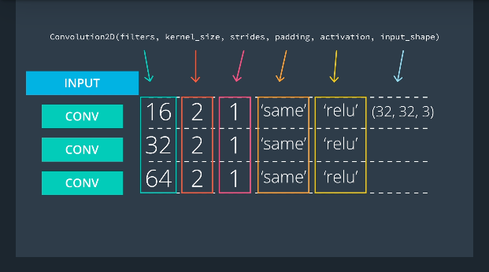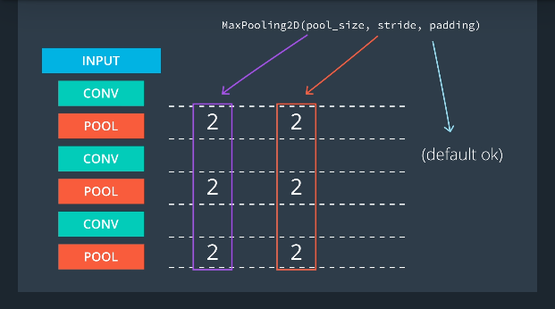

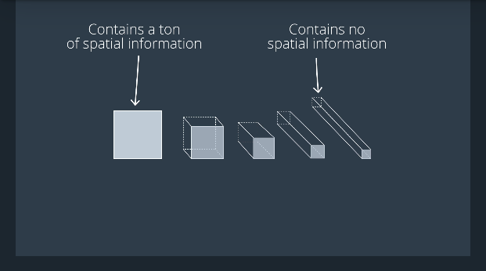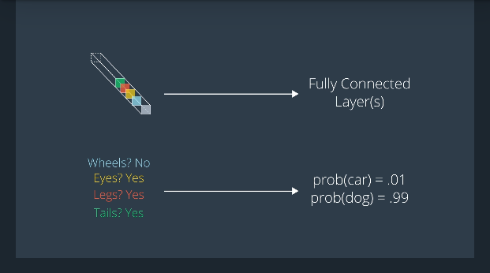

DNN / CNNs are hands on. Don’t be scared to experiment and get ones hands dirty!

Just as with neural networks, we create a CNN in Keras by first creating a Sequential model.

from keras.models import Sequential

We import several layers, including layers that are familiar from neural networks, and new layers that we learned about in this lesson.

from keras.layers import Conv2D, MaxPooling2D, Flatten, Dense

As with neural networks, we add layers to the network by using the .add() method:

model = Sequential()

model.add(Conv2D(filters=16, kernel_size=2, padding='same', activation='relu', input_shape=(32, 32, 3)))

model.add(MaxPooling2D(pool_size=2))

model.add(Conv2D(filters=32, kernel_size=2, padding='same', activation='relu'))

model.add(MaxPooling2D(pool_size=2))

model.add(Conv2D(filters=64, kernel_size=2, padding='same', activation='relu'))

model.add(MaxPooling2D(pool_size=2))

model.add(Flatten())

model.add(Dense(500, activation='relu'))

model.add(Dense(10, activation='softmax'))

The network begins with a sequence of three convolutional layers, followed by max pooling layers. These first six layers are designed to take the input array of image pixels and convert it to an array where all of the spatial information has been squeezed out, and only information encoding the content of the image remains. The array is then flattened to a vector in the seventh layer of the CNN. It is followed by two dense layers designed to further elucidate the content of the image. The final layer has one entry for each object class in the dataset, and has a softmax activation function, so that it returns probabilities.

NOTE: In the video, you might notice that convolutional layers are specified with Convolution2D instead of Conv2D. Either is fine for Keras 2.0, but Conv2D is preferred.

Things to Remember

Always add a ReLU activation function to the Conv2D layers in your CNN. With the exception of the final layer in the network, Dense layers should also have a ReLU activation function.

When constructing a network for classification, the final layer in the network should be a Dense layer with a softmax activation function. The number of nodes in the final layer should equal the total number of classes in the dataset.

**CNNs in Keras**

If you have not yet launched a GPU-enabled server with AWS, you are strongly encouraged to do so before running the notebooks from this video. While it is possible to train the notebooks on your CPU, an AWS GPU instance will be much faster.

The Jupyter notebooks described in the video can be accessed from the aind2-cnn GitHub repository. Navigate to the cifar10-classification/ folder and open cifar10_mlp.ipynb and cifar10_cnn.ipynb.

A Note on the Validation Set

Earlier in the lesson, we trained a neural network with validation by setting the validation_split argument in model.fit to 0.2. This removed the final 20% of the training data, which was instead used as validation data. In the notebook for this video, instead of having Keras split off the validation set for us, we hard-code the split ourselves.

(DONE - miniproject)

**Image Augmentation in Keras**

Want scale and rotational invariance. Image augmentation can help with this. CNNs have some built in translation invariance. 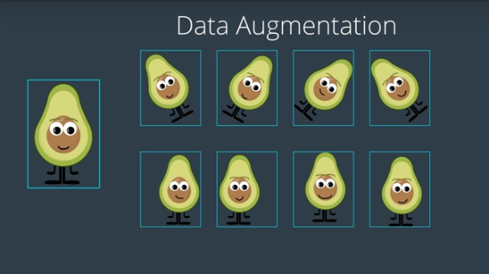

If you have not yet launched a GPU-enabled server with AWS, you are strongly encouraged to do so before running the notebook from this video. While it is possible to train the notebook on your CPU, an AWS GPU instance will be much faster.

The Jupyter notebook described in the video can be accessed from the aind2-cnn GitHub repository. Navigate to the cifar10-augmentation/ folder and open cifar10_augmentation.ipynb.

Note on steps_per_epoch

Recall that fit_generator took many parameters, including

steps_per_epoch = x_train.shape[0] / batch_size

where x_train.shape[0] corresponds to the number of unique samples in the training dataset x_train. By setting steps_per_epoch to this value, we ensure that the model sees x_train.shape[0] augmented images in each epoch.

(Done - miniproject)

**Groundbreaking CNN Architectures**

* Check out the AlexNet paper! – ReLU and Dropout
* Read more about VGGNet here. – Pooling
* The ResNet paper can be found here. – Skipping Layers

**Visualizing CNNs**

<http://cs231n.github.io/understanding-cnn/>

<https://experiments.withgoogle.com/what-neural-nets-see>

<https://blog.keras.io/how-convolutional-neural-networks-see-the-world.html>

<https://www.youtube.com/watch?v=AgkfIQ4IGaM&t=78s>

<https://openai.com/blog/adversarial-example-research/>

<https://deepdreamgenerator.com/>

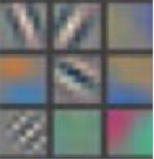

Example patterns that cause activations in the first layer of the network. These range from simple diagonal lines (top left) to green blobs (bottom middle).

The images above are from Matthew Zeiler and Rob Fergus' deep visualization toolbox, which lets us visualize what each layer in a CNN focuses on.

Each image in the above grid represents a pattern that causes the neurons in the first layer to activate - in other words, they are patterns that the first layer recognizes. The top left image shows a -45 degree line, while the middle top square shows a +45 degree line. These squares are shown below again for reference.

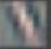

As visualized here, the first layer of the CNN can recognize -45 degree lines.

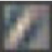

The first layer of the CNN is also able to recognize +45 degree lines, like the one above.

Let's now see some example images that cause such activations. The below grid of images all activated the -45 degree line. Notice how they are all selected despite the fact that they have different colors, gradients, and patterns.

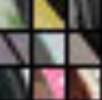

So, the first layer of our CNN clearly picks out very simple shapes and patterns like lines and blobs.

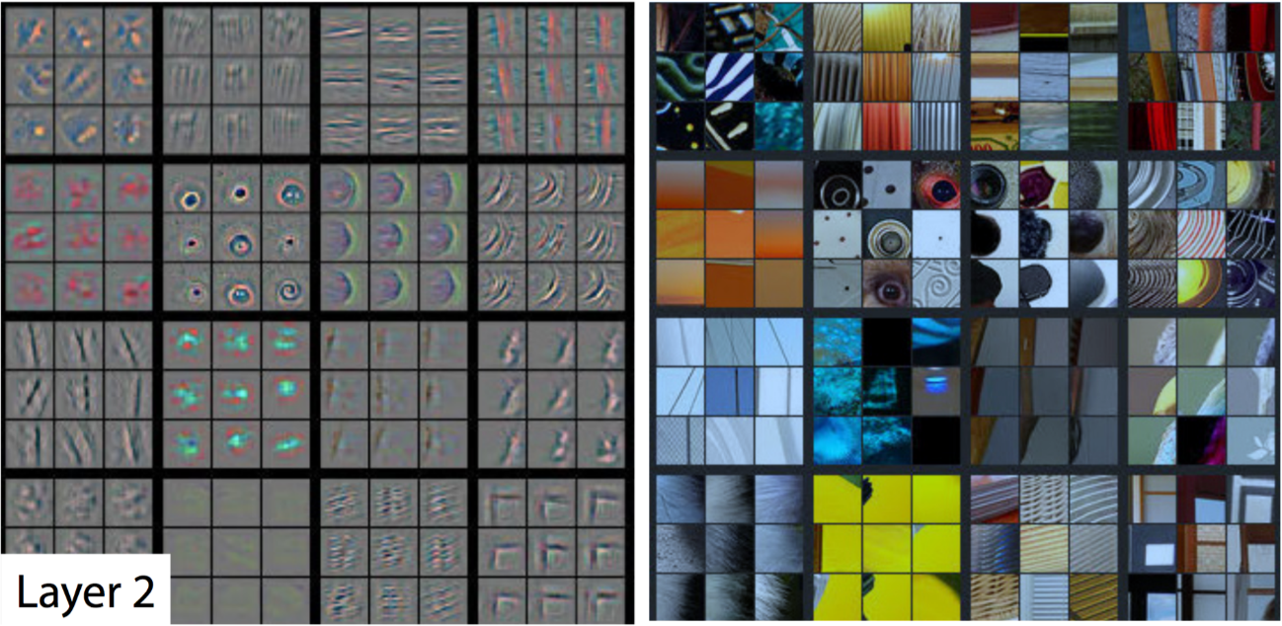

A visualization of the second layer in the CNN. Notice how we are picking up more complex ideas like circles and stripes. The gray grid on the left represents how this layer of the CNN activates (or "what it sees") based on the corresponding images from the grid on the right.

The second layer of the CNN captures complex ideas.

As you see in the image above, the second layer of the CNN recognizes circles (second row, second column), stripes (first row, second column), and rectangles (bottom right).

The CNN learns to do this on its own. There is no special instruction for the CNN to focus on more complex objects in deeper layers. That's just how it normally works out when you feed training data into a CNN.

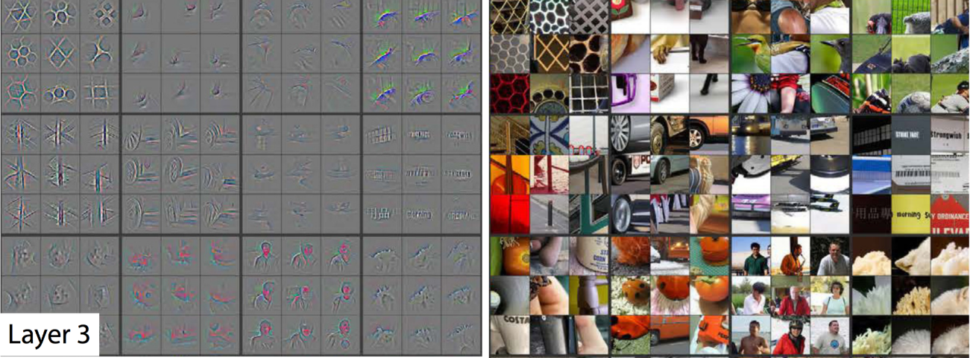

A visualization of the third layer in the CNN. The gray grid on the left represents how this layer of the CNN activates (or "what it sees") based on the corresponding images from the grid on the right.

The third layer picks out complex combinations of features from the second layer. These include things like grids, and honeycombs (top left), wheels (second row, second column), and even faces (third row, third column).

We'll skip layer 4, which continues this progression, and jump right to the fifth and final layer of this CNN.

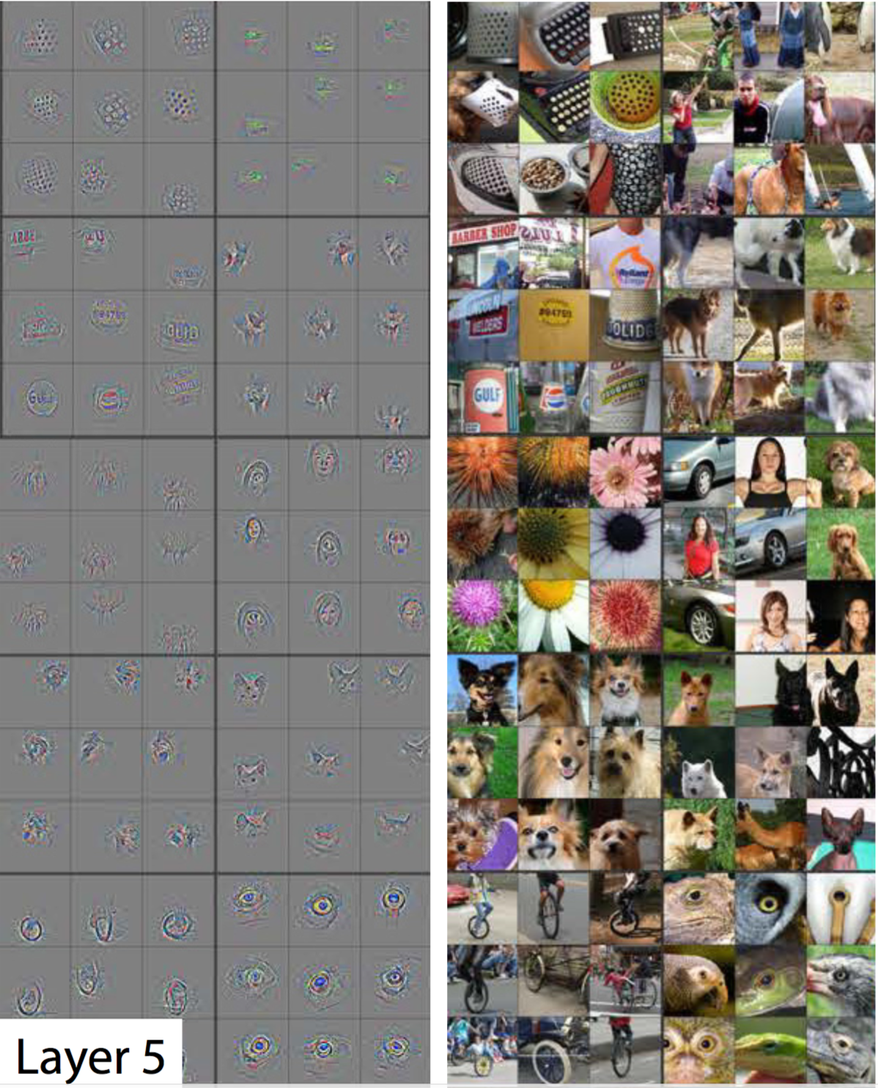

A visualization of the fifth and final layer of the CNN. The gray grid on the left represents how this layer of the CNN activates (or "what it sees") based on the corresponding images from the grid on the right.

The last layer picks out the highest order ideas that we care about for classification, like dog faces, bird faces, and bicycles.

**Transfer Learning (leave the trunk, train the head)**

Transfer learning involves taking a pre-trained neural network and adapting the neural network to a new, different data set.

Depending on both:

the size of the new data set, and

the similarity of the new data set to the original data set

the approach for using transfer learning will be different. There are four main cases:

new data set is small, new data is similar to original training data

new data set is small, new data is different from original training data

new data set is large, new data is similar to original training data

new data set is large, new data is different from original training data

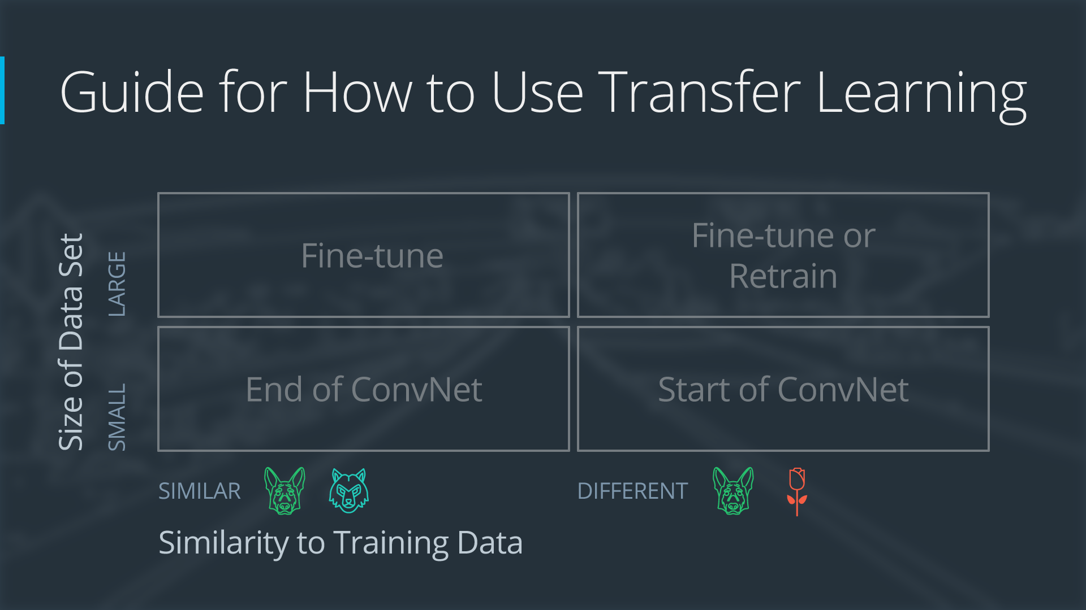

Four Cases when Using Transfer Learning

A large data set might have one million images. A small data could have two-thousand images. The dividing line between a large data set and small data set is somewhat subjective. Overfitting is a concern when using transfer learning with a small data set.

Images of dogs and images of wolves would be considered similar; the images would share common characteristics. A data set of flower images would be different from a data set of dog images.

Each of the four transfer learning cases has its own approach. In the following sections, we will look at each case one by one.

Demonstration Network

To explain how each situation works, we will start with a generic pre-trained convolutional neural network and explain how to adjust the network for each case. Our example network contains three convolutional layers and three fully connected layers:

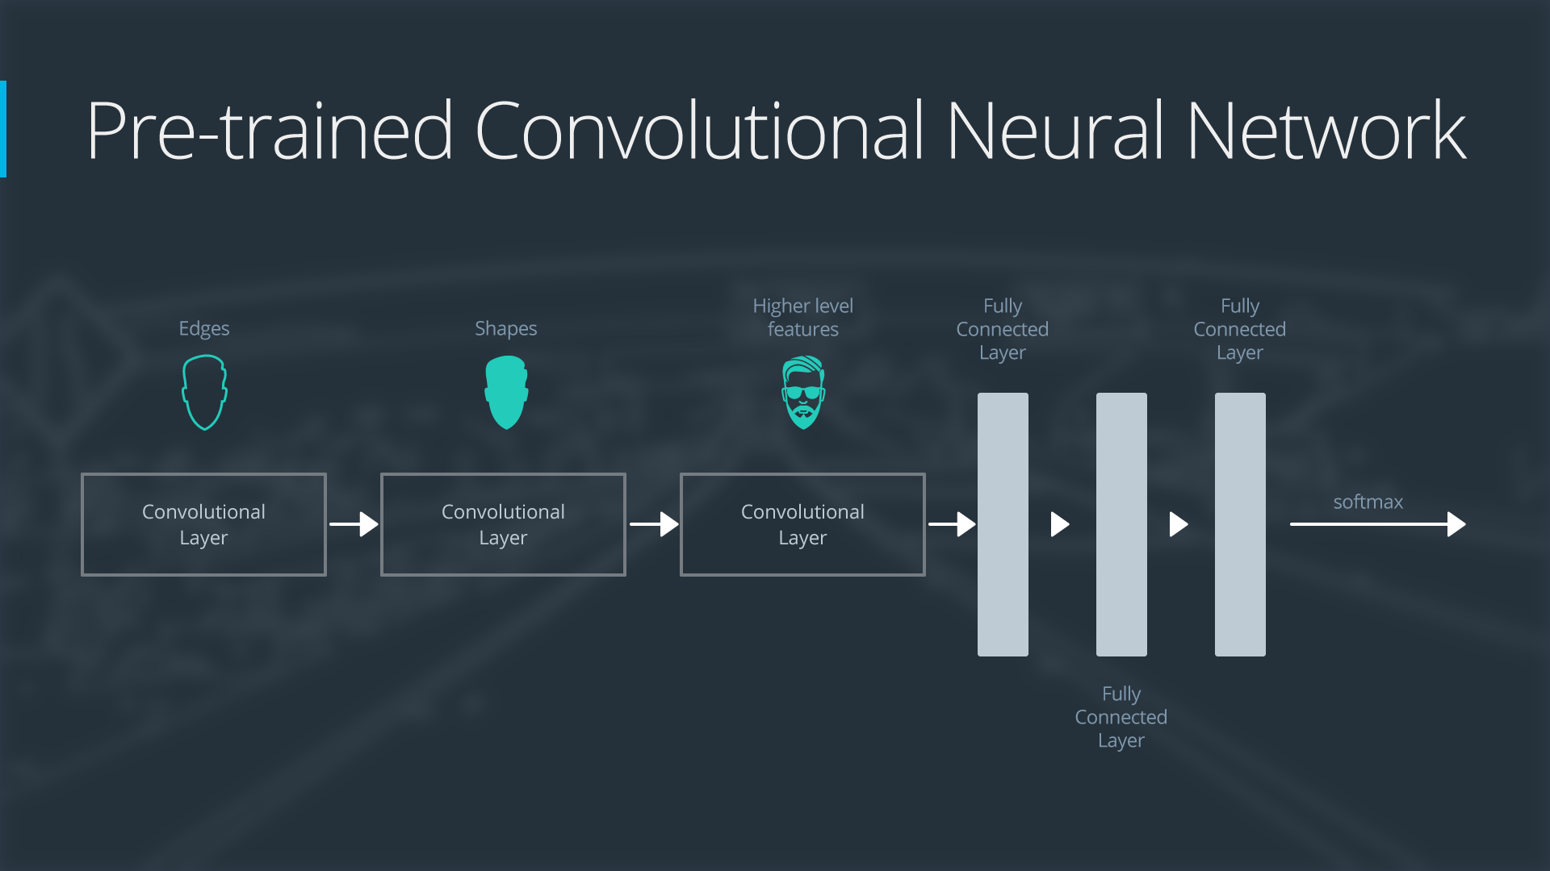

General Overview of a Neural Network

Here is an generalized overview of what the convolutional neural network does:

the first layer will detect edges in the image

the second layer will detect shapes

the third convolutional layer detects higher level features

Each transfer learning case will use the pre-trained convolutional neural network in a different way.

Case 1: Small Data Set, Similar Data

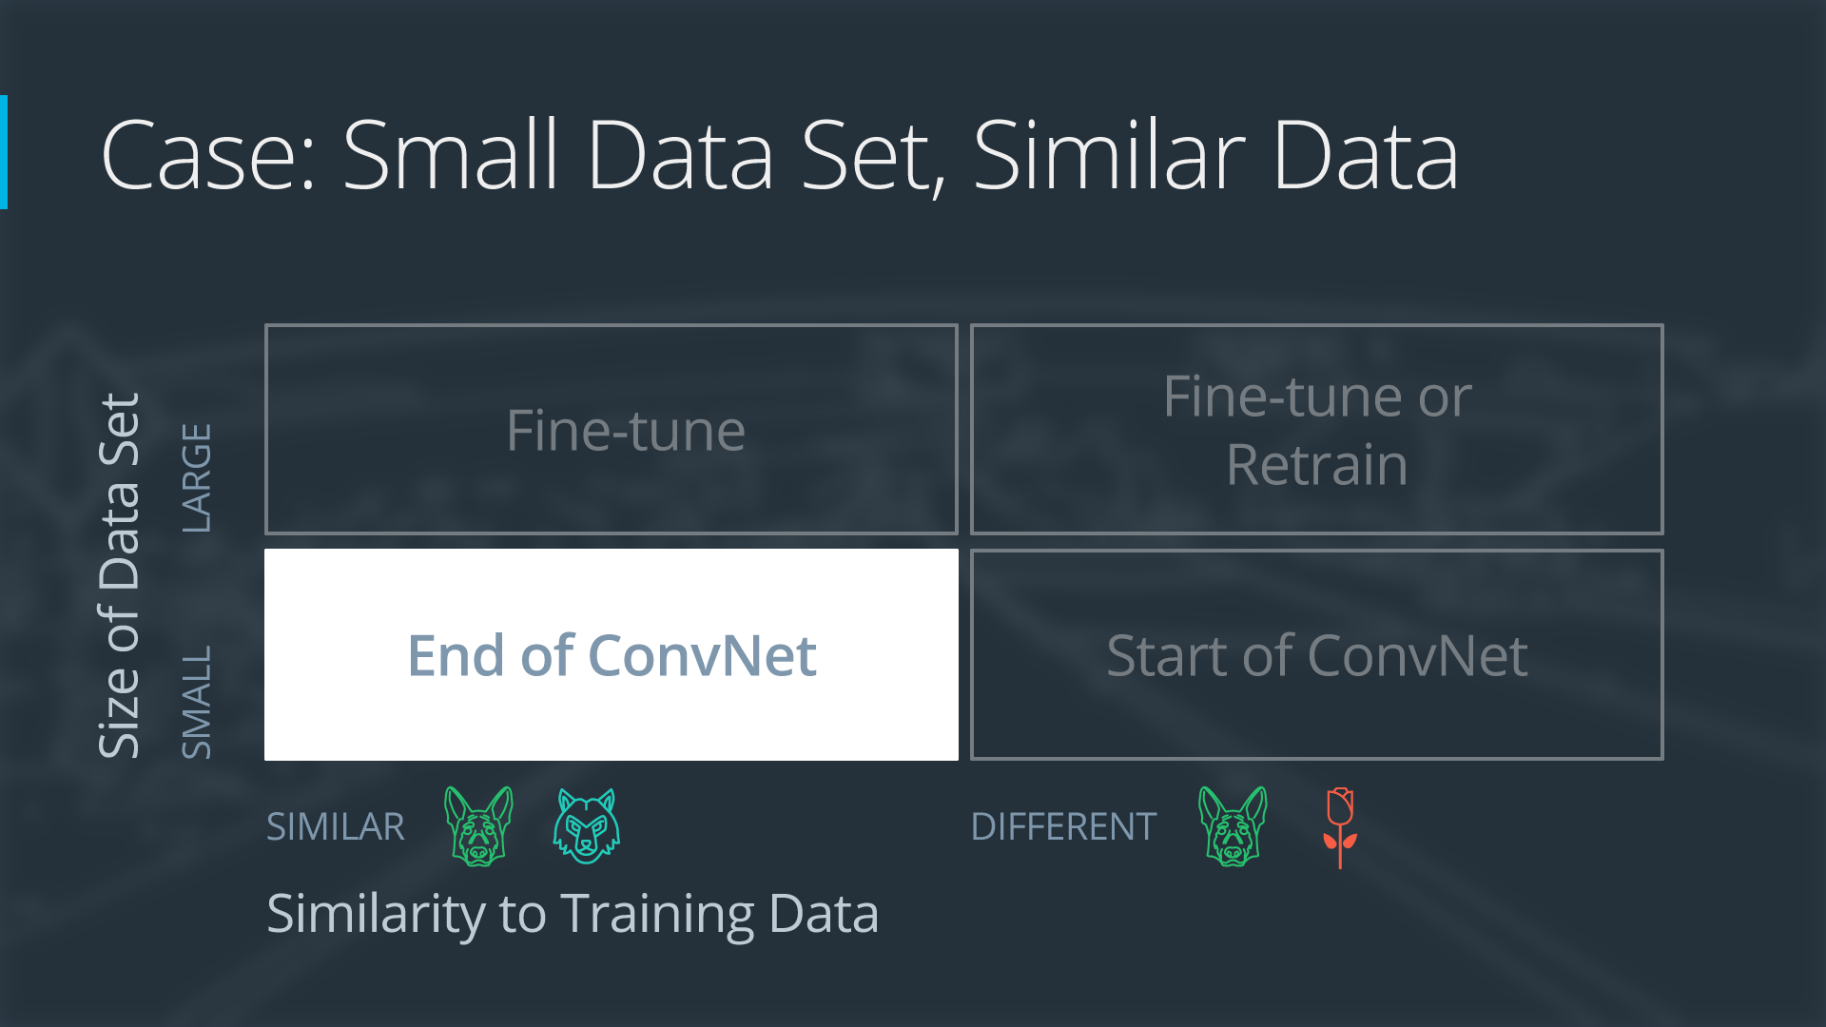

Case 1: Small Data Set with Similar Data

If the new data set is small and similar to the original training data:

slice off the end of the neural network

add a new fully connected layer that matches the number of classes in the new data set

randomize the weights of the new fully connected layer; freeze all the weights from the pre-trained network

train the network to update the weights of the new fully connected layer

To avoid overfitting on the small data set, the weights of the original network will be held constant rather than re-training the weights.

Since the data sets are similar, images from each data set will have similar higher level features. Therefore most or all of the pre-trained neural network layers already contain relevant information about the new data set and should be kept.

Here's how to visualize this approach:

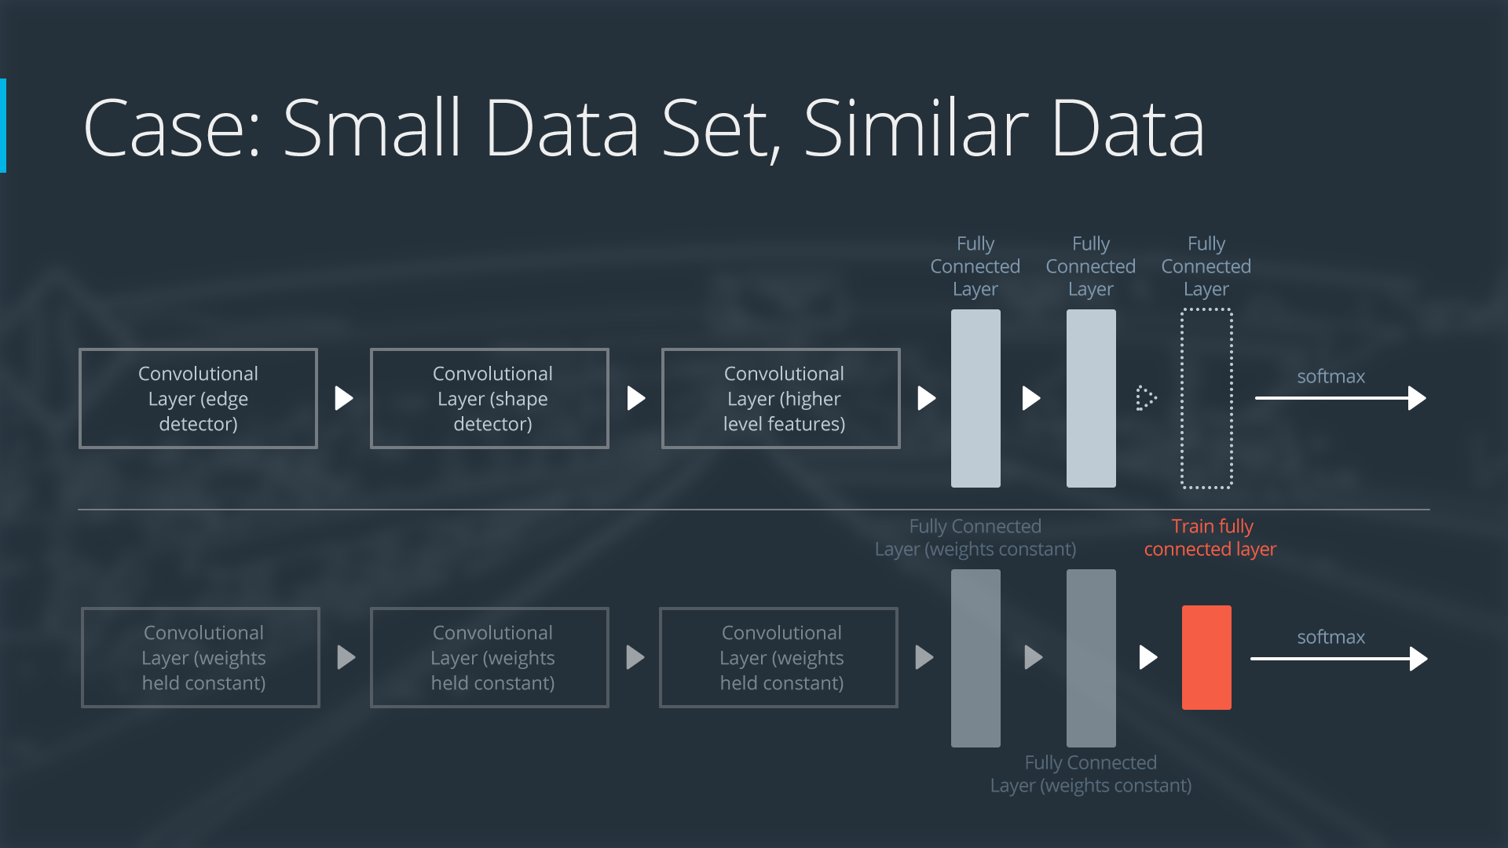

Neural Network with Small Data Set, Similar Data

Case 2: Small Data Set, Different Data

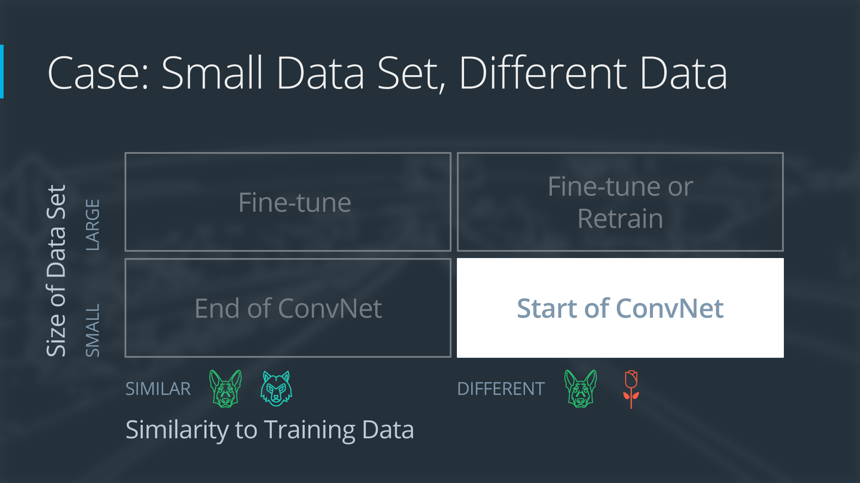

If the new data set is small and different from the original training data:

slice off most of the pre-trained layers near the beginning of the network

add to the remaining pre-trained layers a new fully connected layer that matches the number of classes in the new data set

randomize the weights of the new fully connected layer; freeze all the weights from the pre-trained network

train the network to update the weights of the new fully connected layer

Because the data set is small, overfitting is still a concern. To combat overfitting, the weights of the original neural network will be held constant, like in the first case.

But the original training set and the new data set do not share higher level features. In this case, the new network will only use the layers containing lower level features.

Here is how to visualize this approach:

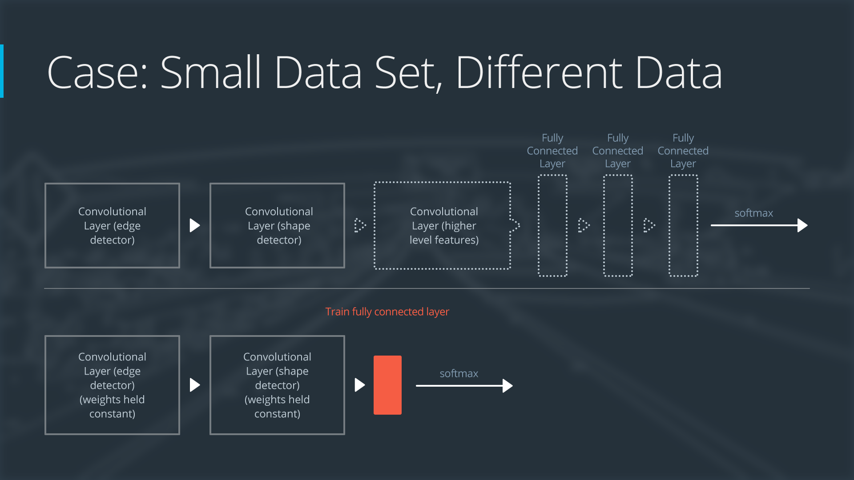

Neural Network with Small Data Set, Different Data

Case 3: Large Data Set, Similar Data

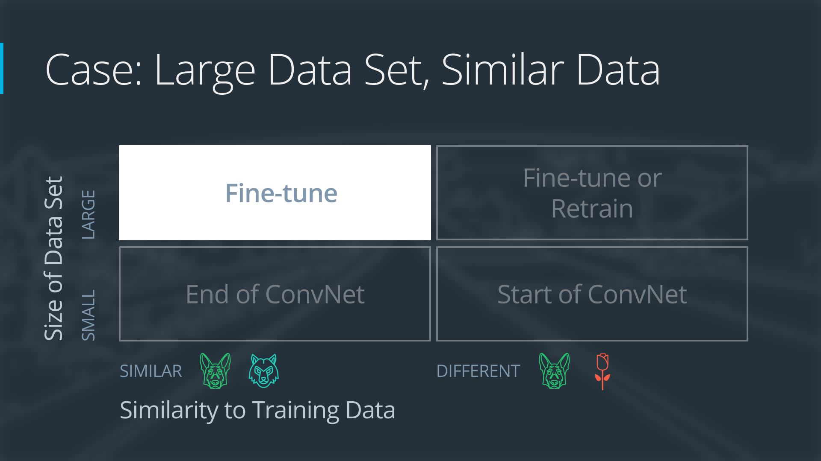

Case 3: Large Data Set, Similar Data

If the new data set is large and similar to the original training data:

remove the last fully connected layer and replace with a layer matching the number of classes in the new data set

randomly initialize the weights in the new fully connected layer

initialize the rest of the weights using the pre-trained weights

re-train the entire neural network

Overfitting is not as much of a concern when training on a large data set; therefore, you can re-train all of the weights.

Because the original training set and the new data set share higher level features, the entire neural network is used as well.

Here is how to visualize this approach:

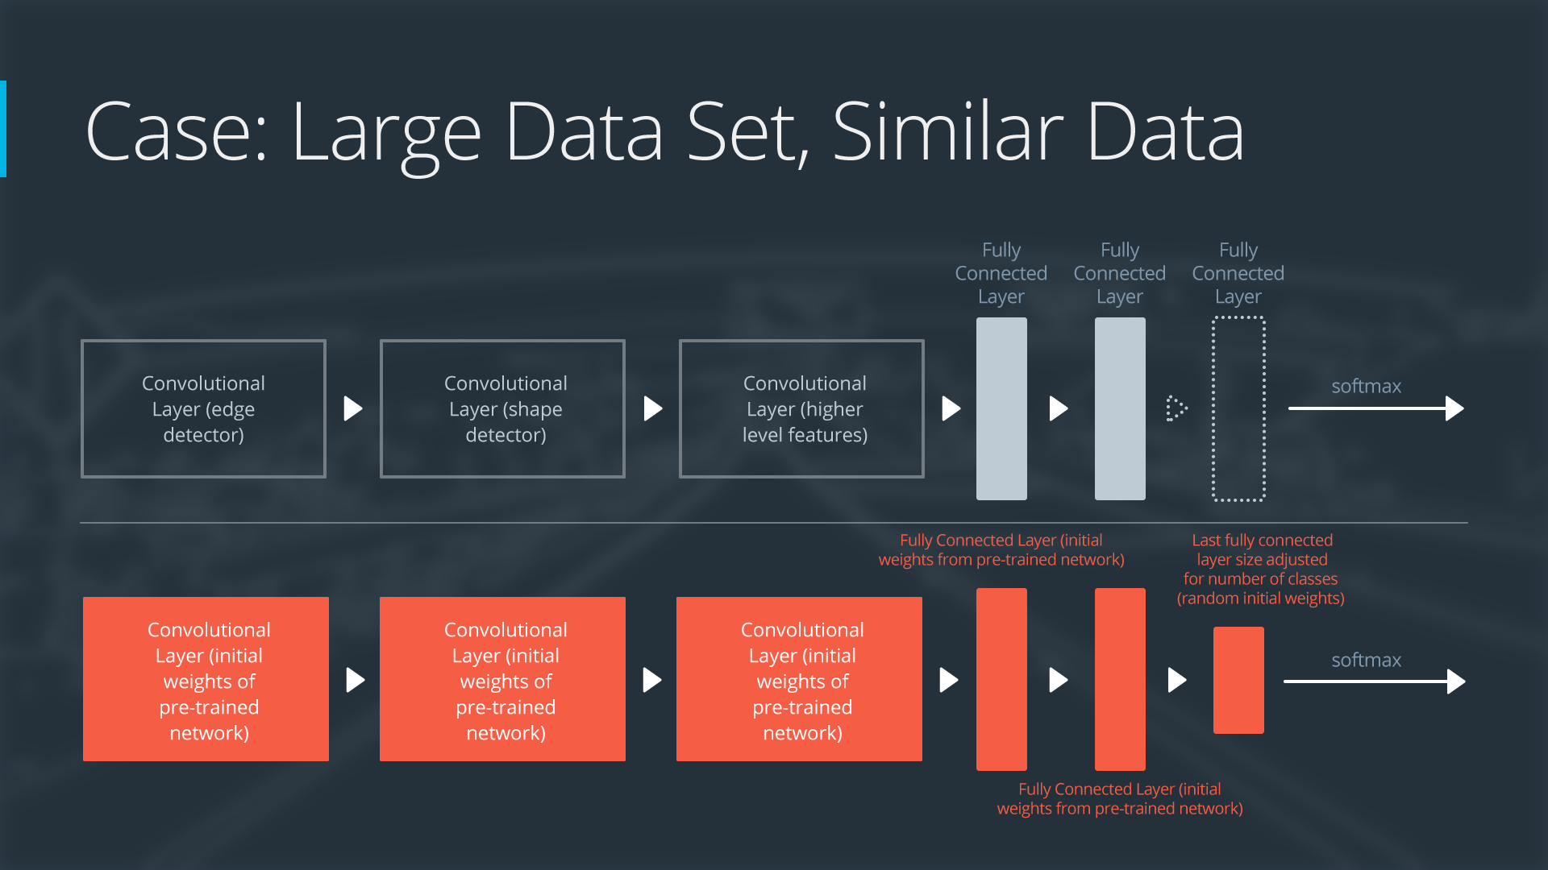

Neural Network with Large Data Set, Similar Data

Case 4: Large Data Set, Different Data

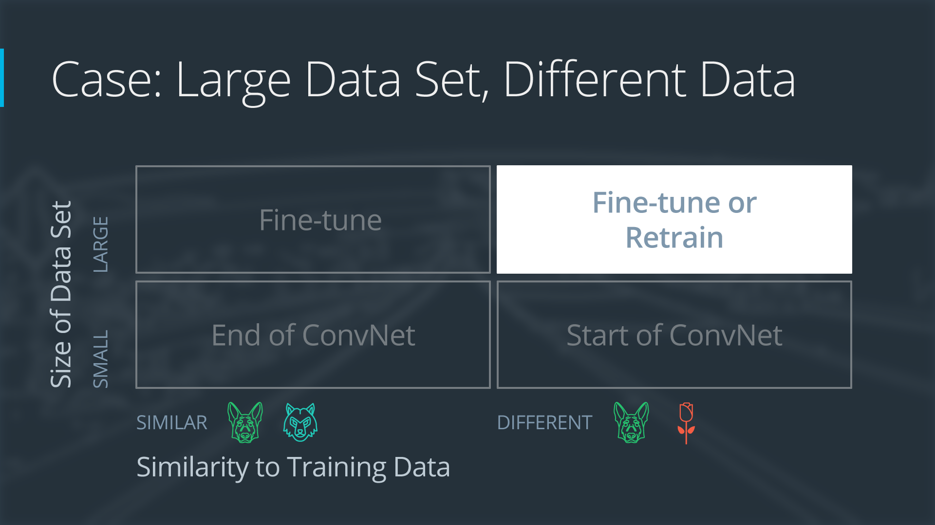

Case 4: Large Data Set, Different Data

If the new data set is large and different from the original training data:

remove the last fully connected layer and replace with a layer matching the number of classes in the new data set

retrain the network from scratch with randomly initialized weights

alternatively, you could just use the same strategy as the "large and similar" data case

Even though the data set is different from the training data, initializing the weights from the pre-trained network might make training faster. So this case is exactly the same as the case with a large, similar data set.

If using the pre-trained network as a starting point does not produce a successful model, another option is to randomly initialize the convolutional neural network weights and train the network from scratch.

Here is how to visualize this approach:

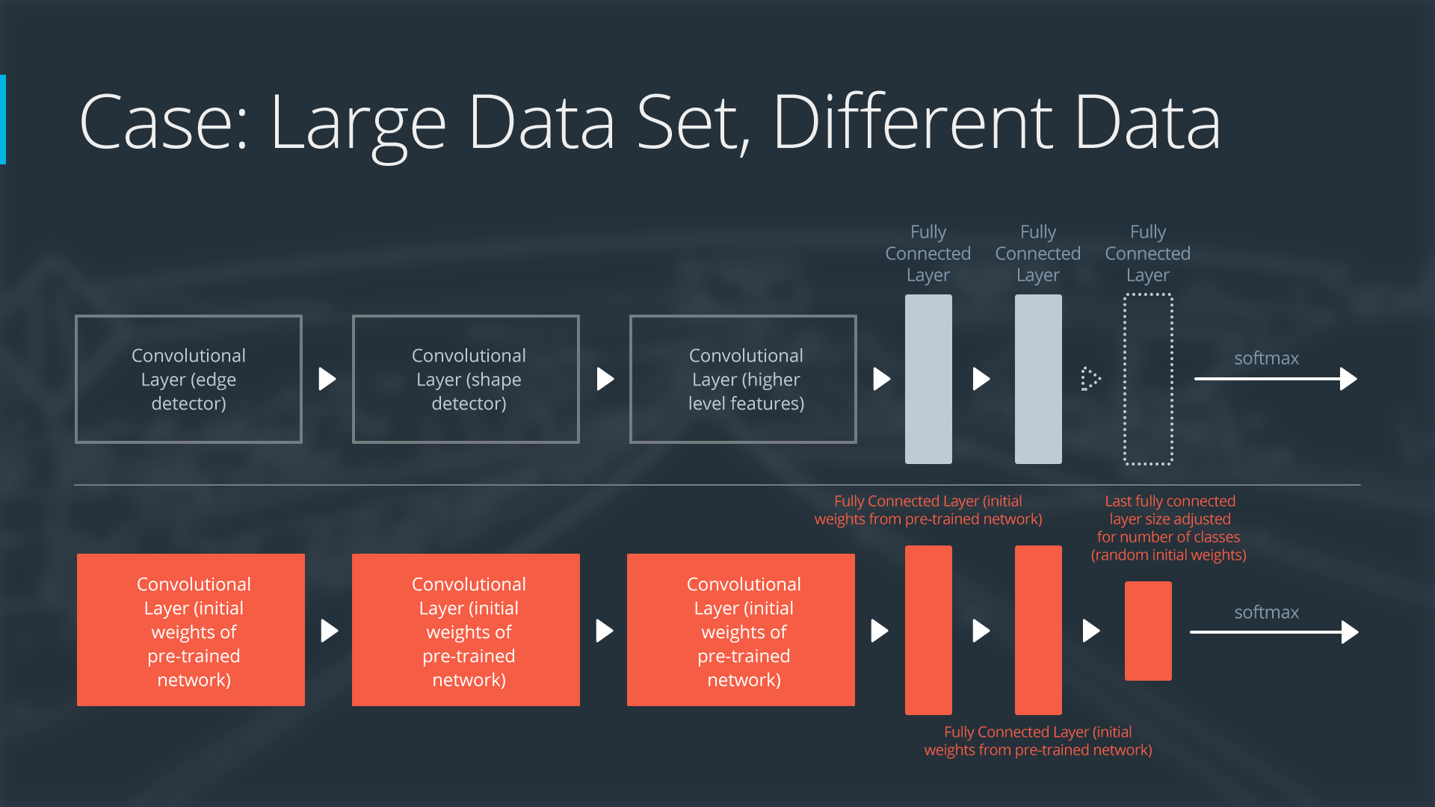

Neural Network with Large Data Set, Different Data

<https://www.nature.com/articles/nature21056.epdf?referrer_access_token=_snzJ5POVSgpHutcNN4lEtRgN0jAjWel9jnR3ZoTv0NXpMHRAJy8Qn10ys2O4tuP9jVts1q2g1KBbk3Pd3AelZ36FalmvJLxw1ypYW0UxU7iShiMp86DmQ5Sh3wOBhXDm9idRXzicpVoBBhnUsXHzVUdYCPiVV0Slqf-Q25Ntb1SX_HAv3aFVSRgPbogozIHYQE3zSkyIghcAppAjrIkw1HtSwMvZ1PXrt6fVYXt-dvwXKEtdCN8qEHg0vbfl4_m&tracking_referrer=edition.cnn.com>

**Transfer Learning in Keras**

<https://github.com/udacity/machine-learning/tree/master/projects/practice_projects/cnn>

The Jupyter notebook described in the video can be accessed from the GitHub respository linked here. Navigate to the transfer-learning/ folder and open transfer_learning.ipynb. If you'd like to learn how to calculate your own bottleneck features, look at bottleneck_features.ipynb. (You may have trouble running bottleneck_features.ipynb on an AWS GPU instance - if so, feel free to use the notebook on your local CPU/GPU instead!)

Uses GAP layers.

(DONE miniproject Test accuracy: 52.8708%)